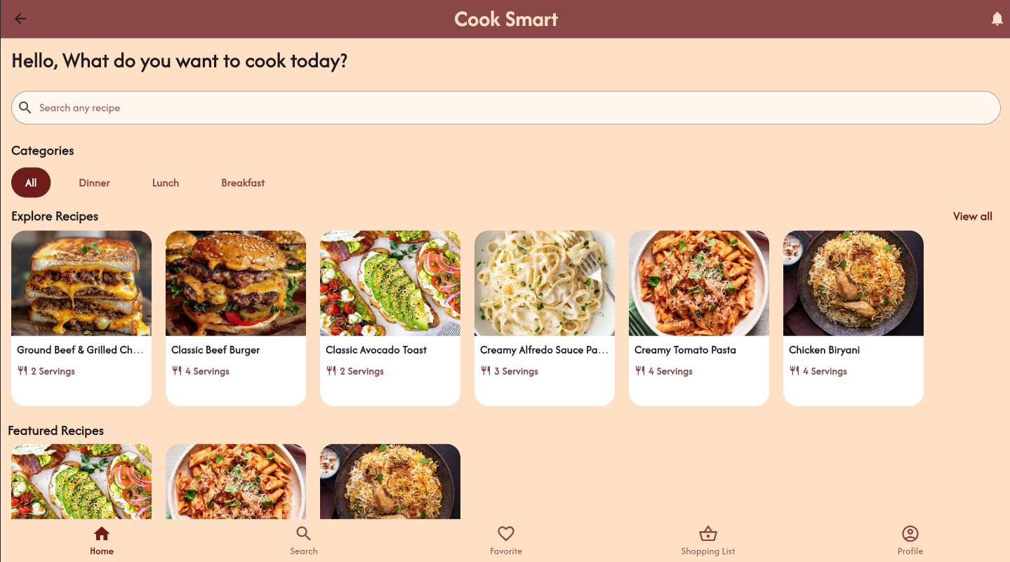

Mobile Application and Development

**Report**

Cook Smart-Food Recipe Application



25.10.2024

**─**

**Submitted by:**

Syeda Anoosha Iqtidar (21SW004)

Minal Azhar (21SW048)

Kashmala Malik (21SW033)

**Submitted to:**

Ms. Mariam Memon

# Introduction

Our app, **Cook Smart** allows finding and seeing recipes along with images and detailed ingredient lists to make cooking easier. In addition to step-by-step instructions, the recipe search feature finds recipes based on ingredients that you already have in your home; it provides ease in changing servings through recipe scale features and lets you create an organized grocery list with just a single tap. It will help ease up on planning, cooking, and having meals or dishes designed to fit your needs.

## Real World Problem Identification

Nowadays where we are heading towards faster and more effective solutions, people want quick food preparation methods that suit one's taste by making use of available ingredients. Most people face problems such as food waste, poor planning of meals, and difficulty in scaling recipes to accommodate different quantities, especially when cooking for sometimes few and then large numbers of people.

Managing shopping lists to avoid mistakes such as forgetting items, and having to make several shopping trips can be quite a challenge to anyone. Traditional recipe platforms do not always offer dynamic tools that cater to these practical needs, leaving users with limited options for meal planning and grocery organization.

**Cook Smart** addresses these challenges by providing:

**Recipe Suggestions Based on Available Ingredients:**

Reducing food waste by allowing users to find recipes that make the best use of what they already have in their kitchen.

**Recipe Scaling for Servings:**

Simplifying portion adjustments, so users can cook for any group size without manually recalculating ingredient quantities.

**Integrated Shopping List Feature:**

Creating organized, accurate shopping lists with a single tap makes it easy to remember all necessary ingredients and avoid multiple trips to the store.

By addressing these everyday meal preparation challenges, **Cook Smart** aims to make cooking more accessible, waste-conscious, and enjoyable for all users.

## Proposed Solution

To address the challenges of meal preparation, food waste, and grocery organization, **Cook Smart** provides a range of innovative, user-friendly features tailored to modern-day needs.

Here’s how the app tackles each key problem area:

**Ingredient-Based Recipe Suggestions:**

**Cook Smart** allows users to input leftover ingredients they already have in their kitchen, instantly generating recipe ideas that incorporate these items. This feature aims to minimize food waste and make use of what’s readily available, saving both time and money. By maximizing ingredient use, users can discover creative meal options they might not have considered otherwise.

**Recipe Scaling for Serving Adjustments:**

Recognizing the common need to adjust recipes for different group sizes, **Cook Smart** includes a recipe scale feature. This allows users to change the serving size, with ingredient quantities automatically recalculated. This saves time and reduces the hassle of manual adjustments, ensuring accurate portions whether cooking for one person or a large group.

**One-Tap Shopping List Creation:**

The application comes with a quick and nicely structured shopping list that collects all required ingredients as chosen in specific recipes. This saves time in stores by preventing one of the most common mistakes in ingredients. Users can view a well-arranged list within seconds, which thus helps them to plan grocery trips better.

**Step-by-Step Photographed Cooking Instructions**

Cook Smart has easy, step-by-step recipes, but with photographs accompanying each step of the preparation process. Thus, it empowers everyone to produce perfect results whatever level of skill one might have in cooking, leading to kitchen confidence and an easy way forward for preparation.

# Responsive User Interfaces

**Mobiles:**

For mobile users, we focused on a compact, yet functional layout. Mobile screens have limited space so the interface was designed to be clean and minimalistic, with elements such as buttons, text fields, and lists scaled appropriately for smaller displays. We ensured that vertical scrolling was smooth, and gestures like taps were easy to perform.



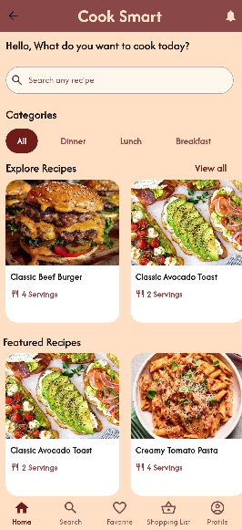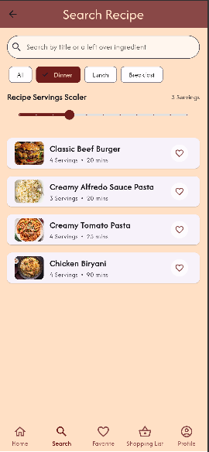

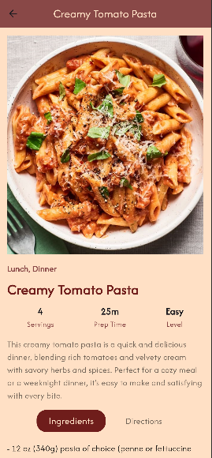

**Tablets:**

On tablets, we optimized the layout to utilize the larger screen area. Instead of the compact layout used on mobile devices, tablets display the recipe with larger columns, making it easier for users to explore more content at once. Additionally, the interface spacing and element sizes were adjusted to prevent the UI from feeling stretched or sparse. This enhances the user experience on medium-sized screens by making navigation more efficient while keeping the visual appeal intact.

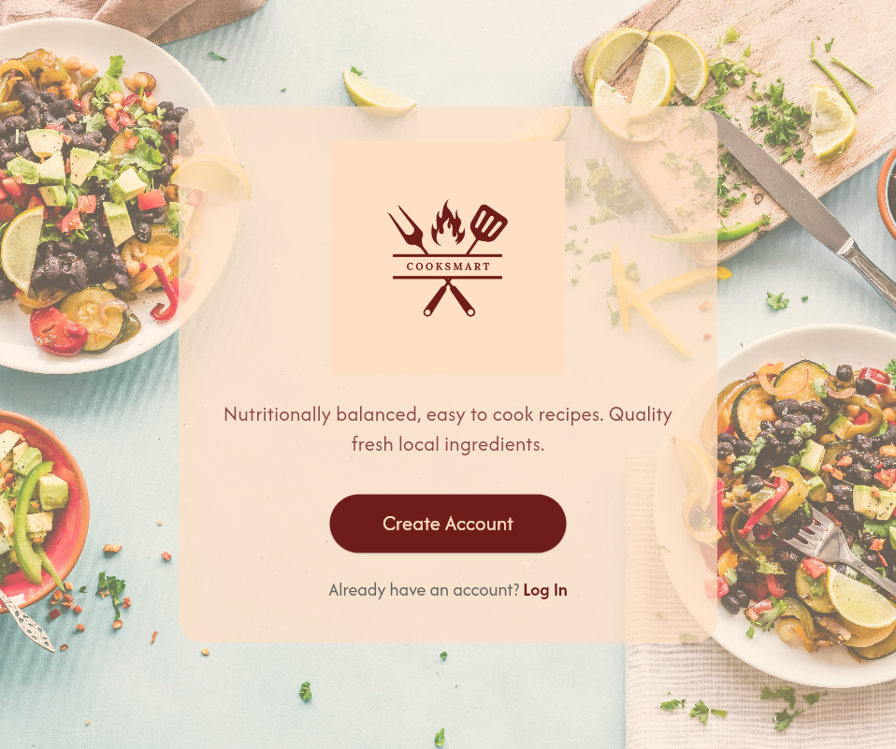

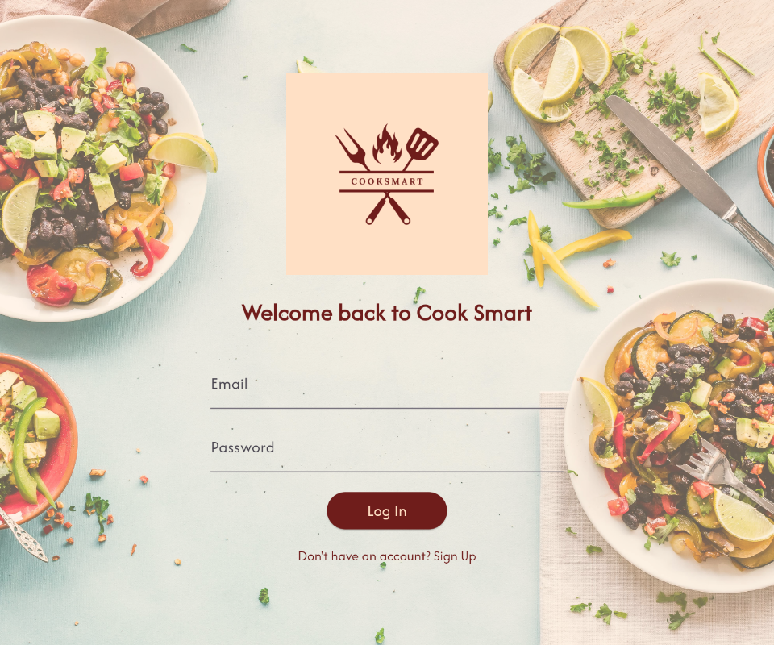

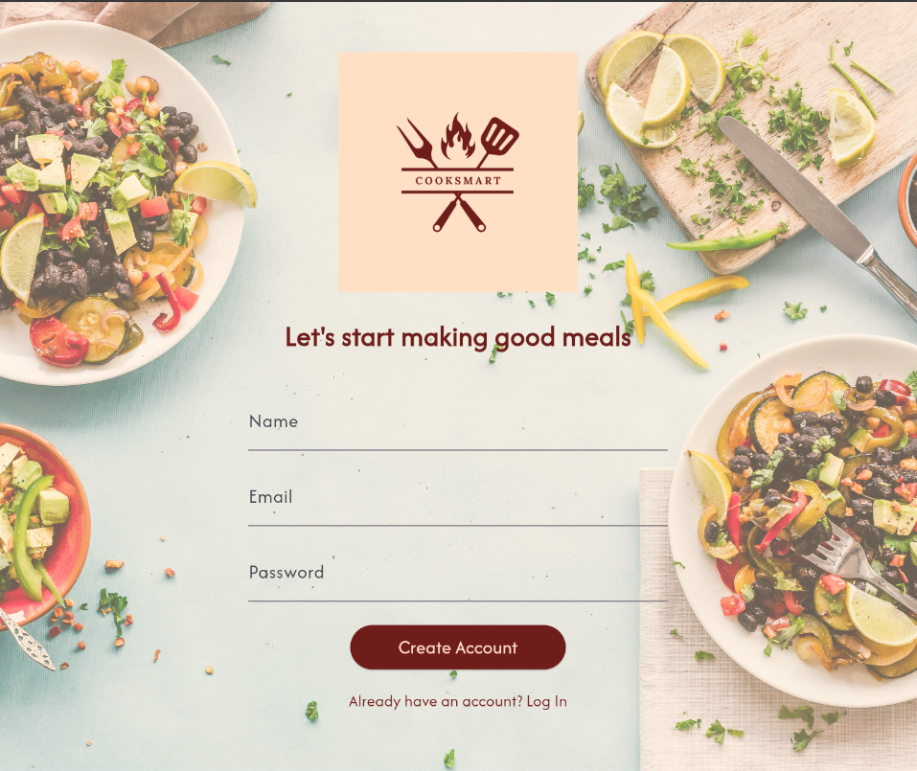

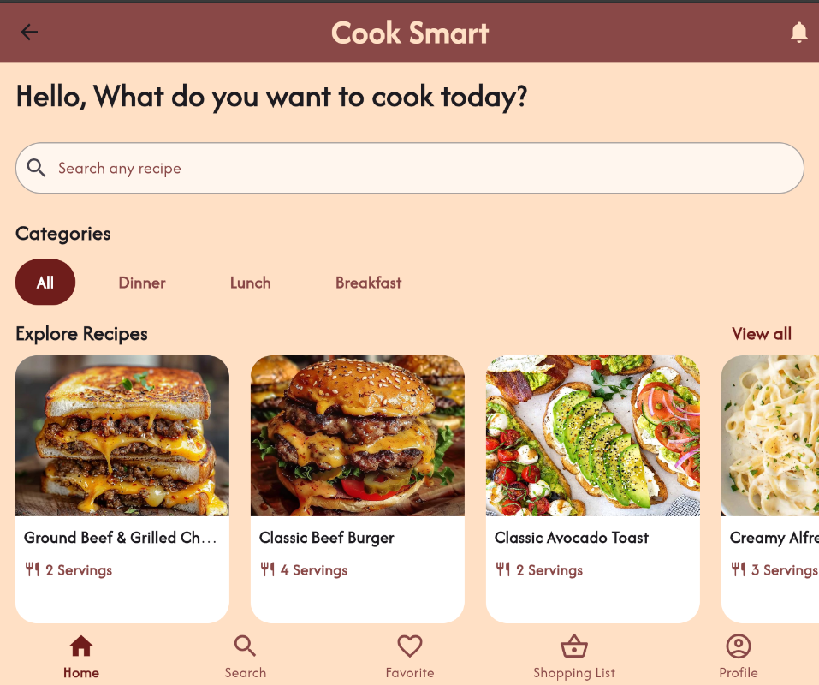

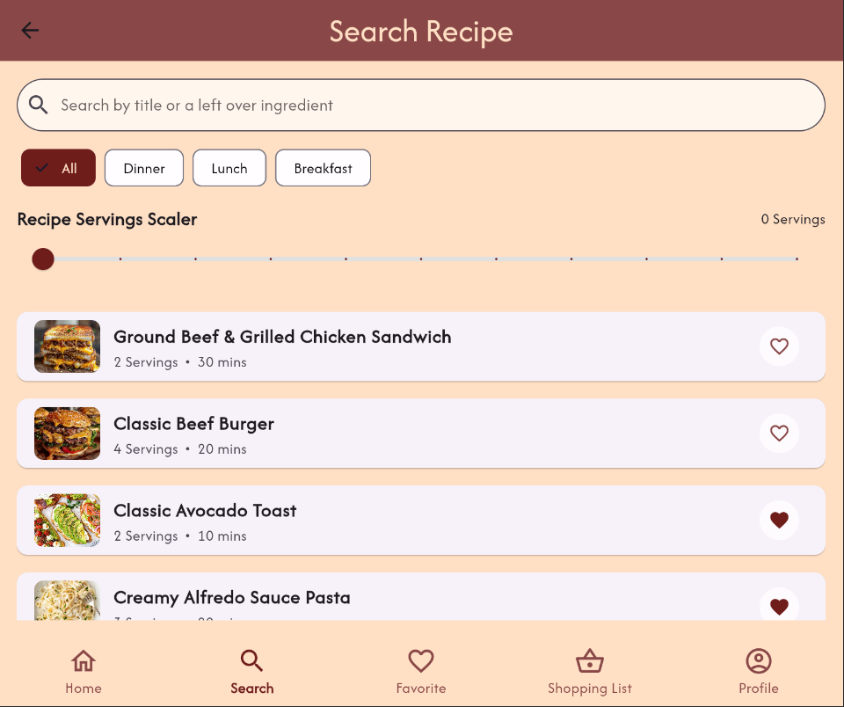

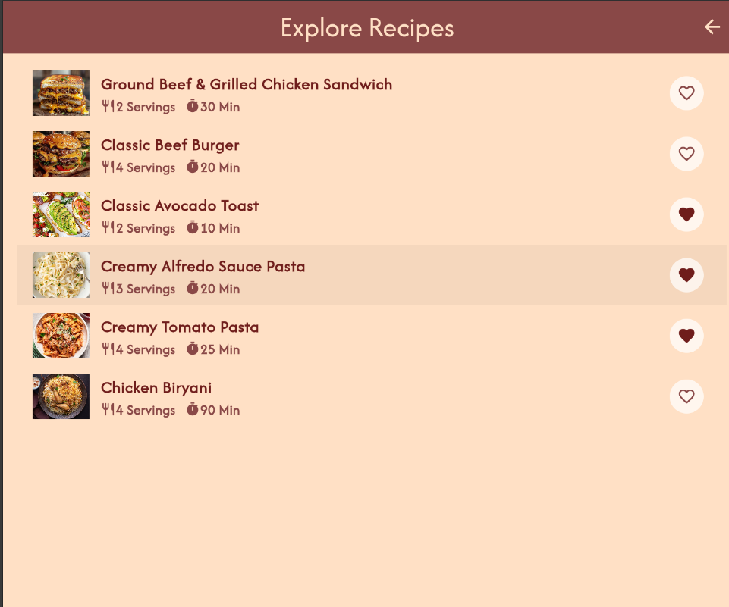

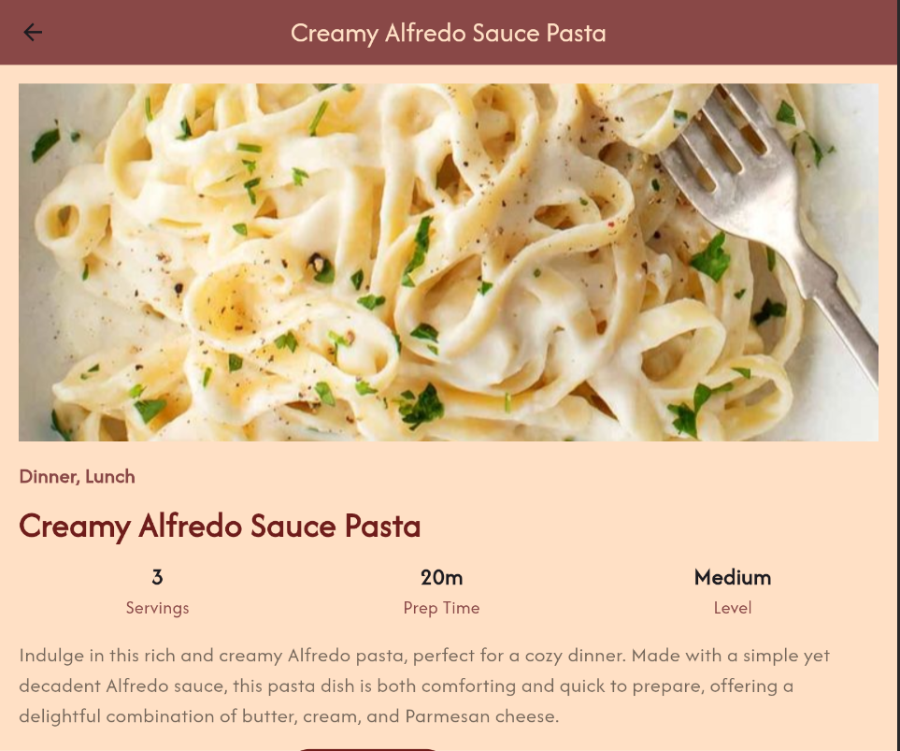

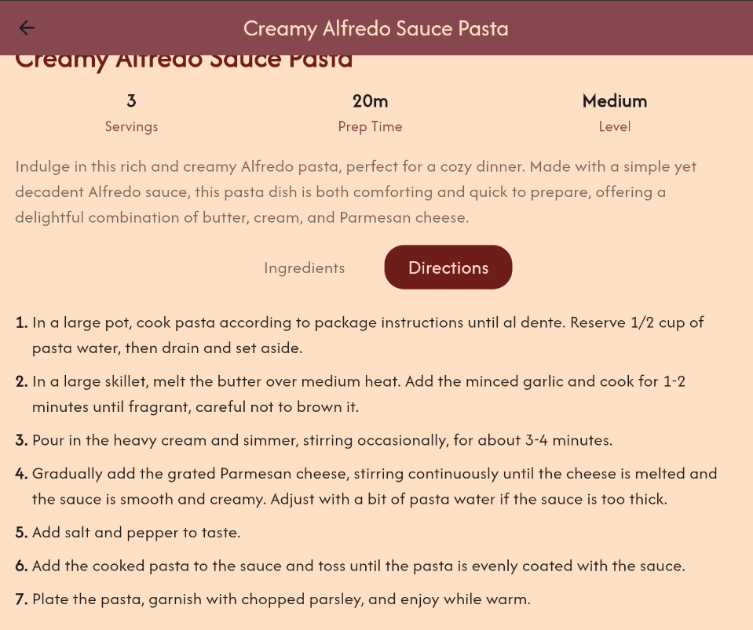

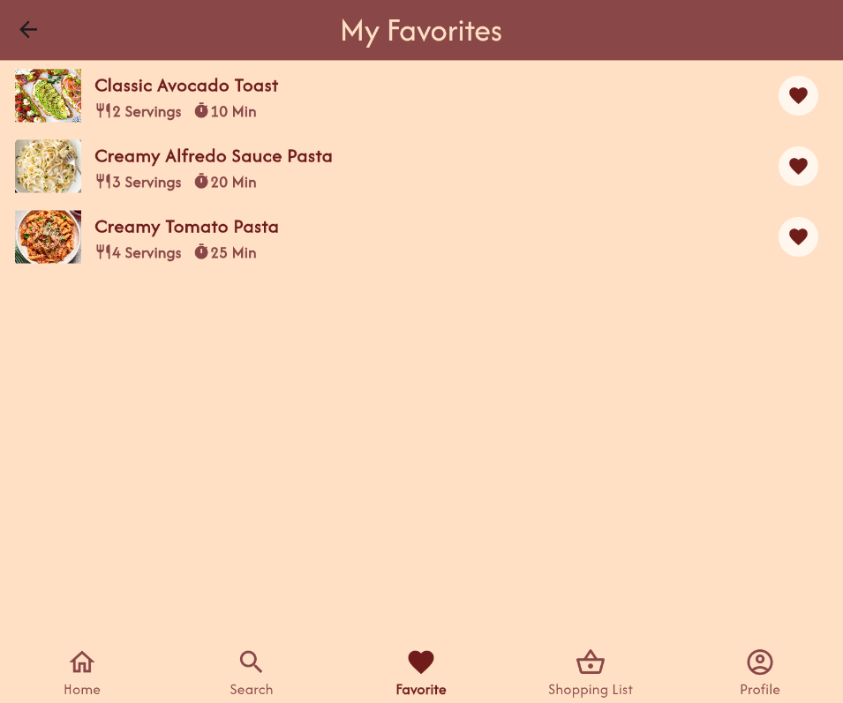



**Laptops:**

For laptop and desktop users, we took full advantage of the extended screen space by expanding the layout for recipes and increasing padding around UI elements. This ensures that the app feels spacious and professional, without overcrowding the screen. Features such as horizontal scrolling for sections like featured recipes were enhanced to give users easy access to more content at a glance. Text size and image quality were adjusted to match the higher resolution typically found on larger displays, improving readability and visual aesthetics.

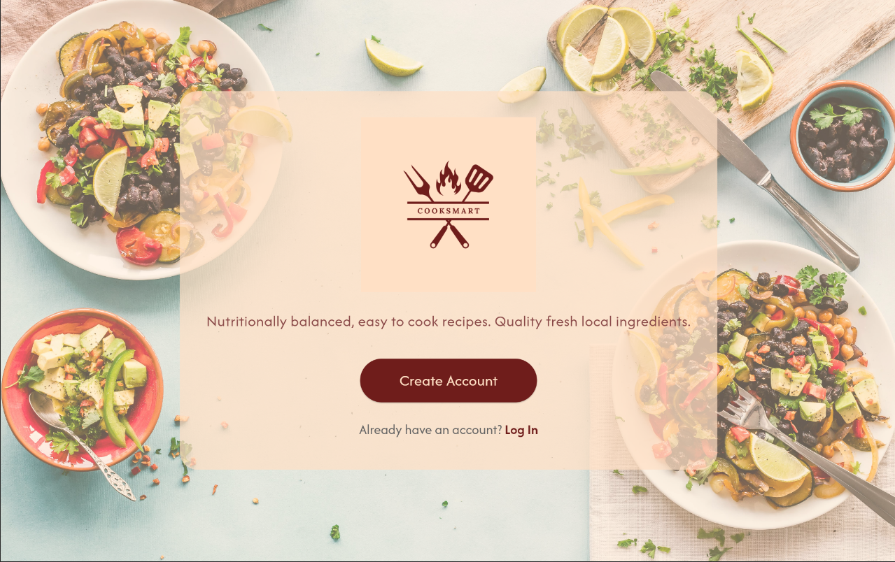

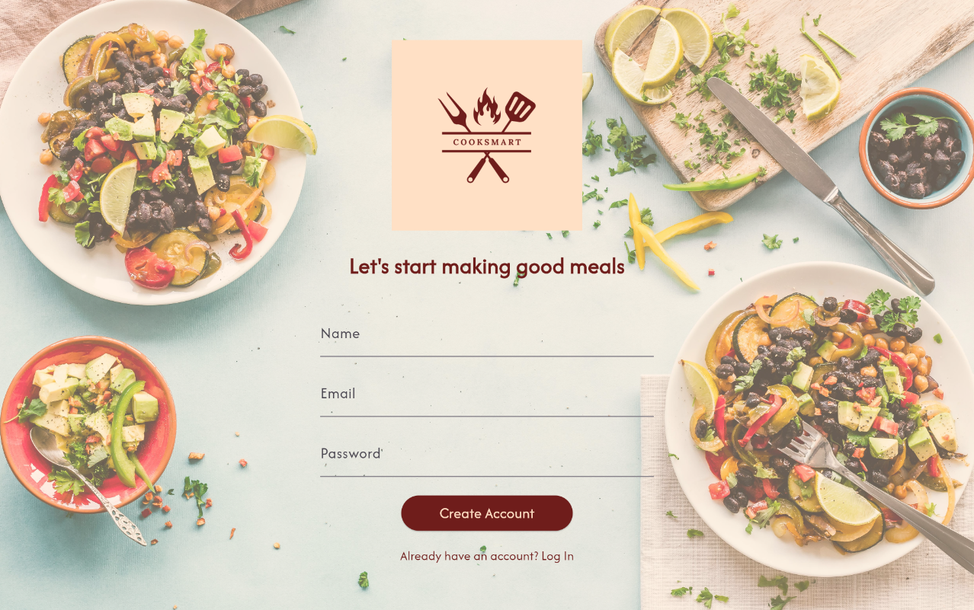

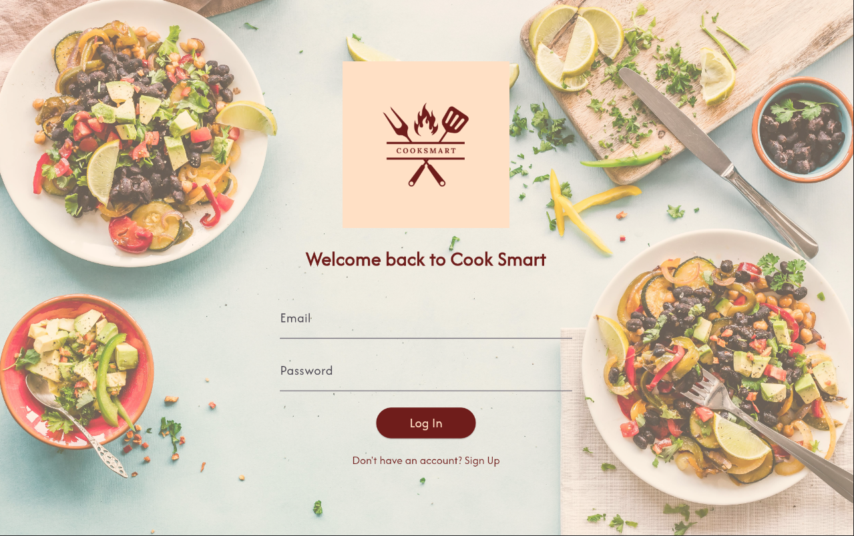



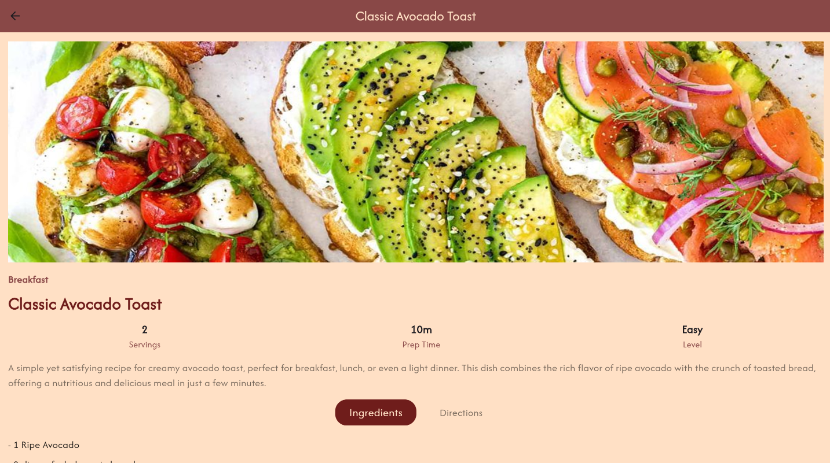

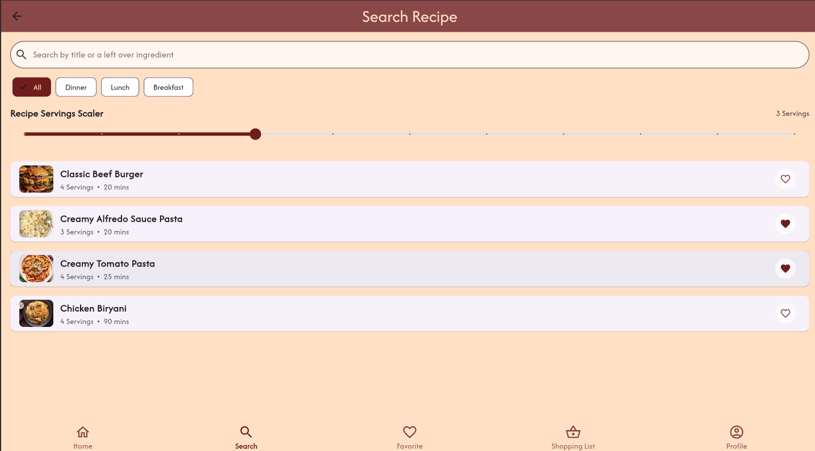

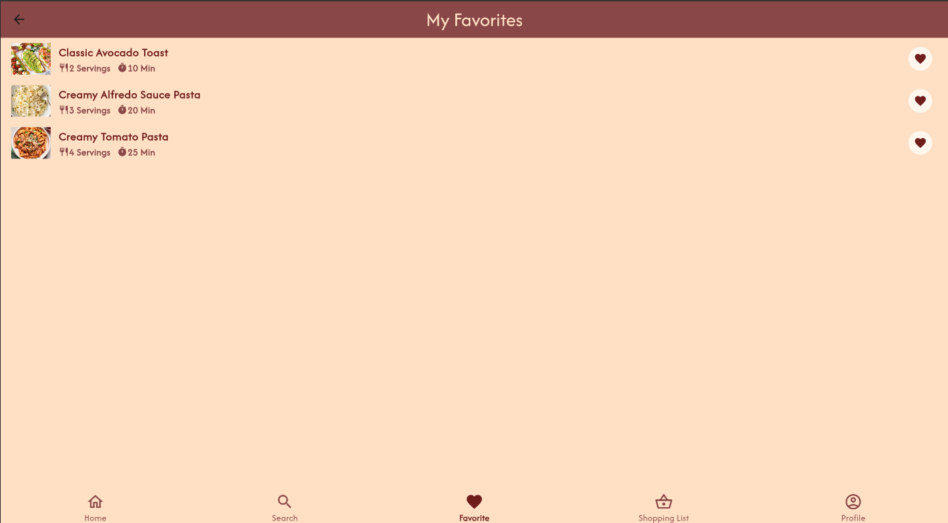

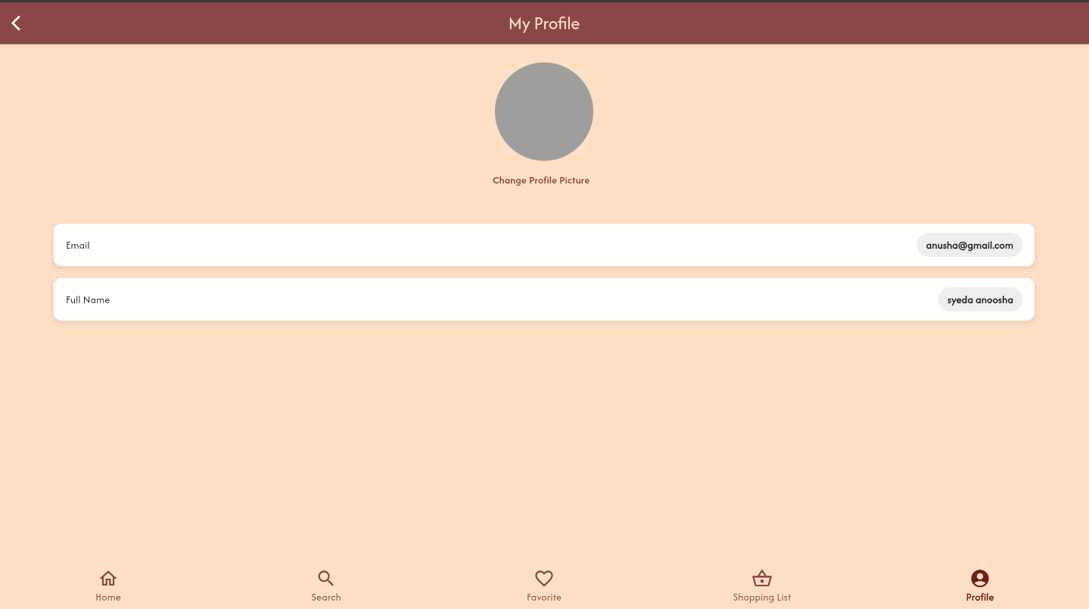

# Data Storage

To justify the use of Firebase Firestore for storing collections (recipes, categories, user details) and asset files for static resources like recipe images, app logos, and background images, here's a structured explanation:

**Why Use Firebase Firestore for Dynamic Collections (Recipes, Categories, User Details)?**

**Scalability and Real-time Updates:**

Firebase Firestore is designed to scale as an application grows. As more users sign up or more recipes are added, Firestore can efficiently handle the increasing volume.

Firestore’s real-time sync capabilities allow us to instantly reflect changes in our app. For example, when a new recipe is added or when a user updates their profile, the changes are immediately synced across all users’ devices. This is essential for maintaining up-to-date content such as new recipes or category updates in a food-related app.

**Flexible Data Structure:**

Firestore provides a flexible, schema-less database that makes it easier to store structured and semi-structured data. We structured our collections into logical groups such as recipes, categories, and users:

**Recipes:** Each recipe includes fields such as title, ingredients, servings, ingredients, category, and directions.

**Categories:** Stored the list of categories, each with fields such as category name.

**User Details:** Store user profiles in the user's collection, capturing details like email, profile picture URL, name, and favorites.

**User Authentication and Data Security:**

With Firebase Authentication integrated, we can securely associate user data (like user details, favorite recipes, or shopping lists) with authenticated users. Firestore rules ensure that only authorized users can access or modify their data. This ensures data privacy, as user information is isolated, and only the logged-in user can modify their profile or preferences.

**Efficient Querying for Recipes and Categories:**

Firestore allows efficient queries, such as retrieving all recipes in a certain category or searching for recipes based on ingredients.

**For example:**

**Query to get all recipes in a category:** This is a common query to display recipes based on user-selected categories.

**Query to search recipes by title or ingredients:** This helps users quickly find the recipes they need.

Firestore supports powerful querying mechanisms, which were critical for our app where users frequently search and filter recipes.

**Why Use Asset Files for Static Resources (Images like Recipe Images, Logos, Backgrounds)?**

**Improved Performance for Static Content:**

Assets (stored locally in the app), such as images for logos, background images, or default recipe images, are immediately available without network latency or additional API requests.

This reduces load times and ensures that crucial branding images (e.g., app logo, background images) are displayed instantly. This is particularly important during the app's initial load or when users are offline.

Static assets are well-suited for content that doesn’t change frequently, like app icons, branding elements, or default placeholders.

**Offline Access:**

By storing frequently used static resources (e.g., logos, background images, default recipe images) as assets in the app, users can access these images even when they are offline. This improves the app’s reliability in low-connectivity environments.

This is especially useful in apps where users may want to access basic features or browse preloaded recipes and categories when they don’t have an active internet connection.

**Smaller Database Size:**

Keeping only dynamic content in Firestore ensures that the database is used efficiently, without cluttering it with static or rarely-changing resources.

**APIs/Packages/Plug-ins**

In developing our app, we made careful decisions about the technologies and dependencies used to ensure optimal performance, user experience, and maintainability. Below is a justification of why we chose each of these essential packages:

1. **Google Fonts:**

We incorporated the google_fonts package to enhance the app’s visual appeal and ensure consistency in typography across different platforms. Using custom fonts improves readability and adds a unique personality to the app’s design.

With google_fonts, we could easily access a wide range of fonts from Google’s library without needing to bundle large font files within the app, which helps reduce the app's size while still offering aesthetic variety.

1. **Firebase Core:**

The firebase_core package is essential for initializing Firebase services in the app. Firebase is central to our app's functionality, serving as the backbone for various services like authentication, cloud storage, and real-time database interaction.

By integrating Firebase Core, we establish a reliable connection between our app and Firebase's comprehensive suite of tools, ensuring secure and efficient data management.

1. **Firebase Auth:**

For user authentication, we implemented firebase_auth to enable secure and seamless login and signup processes. This package allows users to authenticate using various methods, including email/password, Google, and other OAuth providers.

Security is a major concern, and Firebase Authentication provides a robust and scalable solution for handling user accounts, allowing us to focus on building features rather than managing security vulnerabilities.

1. **Cloud Firestore:**

We utilized cloud_firestore to handle the app’s database needs. Firestore offers a cloud-based NoSQL database that scales efficiently with low-latency queries. This database is crucial for storing and retrieving user data, recipes, and other dynamic content in real time.

Firestore's integration with Firebase’s ecosystem allows for easy querying, real-time synchronization, and secure data storage, making it ideal for handling our app's backend.

1. **Provider:**

To manage the state across the application, we chose the provider package. In complex apps, managing state efficiently is key to ensuring smooth navigation and data consistency. By using a provider, we can decouple business logic from the UI, making the app more maintainable and scalable.

This approach simplifies state management, making it easier to pass data between widgets and keep the UI responsive and up-to-date without unnecessary rebuilds.

1. **Image Picker:**

The image_picker package enables users to easily upload profile pictures and other images in the app by selecting photos from their device's gallery or capturing new ones via the camera. Providing an intuitive and familiar interface for uploading images enhances the user experience.

Moreover, integrating image selection and uploading functionality is critical in a recipe app where visuals play a significant role in user engagement and content creation.

**Issues and Bugs Encountered and Resolved during Development**

Some of the issues that we encountered during the development of the **Cook Smart** recipe app and how we tackled them are as follows:

**Real-Time Database Updates Not Reflecting Instantly**

* **Issue:** Changes made to the ingredient list in Firebase weren’t showing up immediately in the app.
* **Cause:** Firebase wasn’t automatically pushing updates to the app due to the lack of real-time listeners, requiring manual refreshes to retrieve new data.
* **Solution:** Implemented Firebase's real-time listeners and used StreamBuilder in Flutter to actively listen for database changes. This allowed updates to display instantly without requiring a manual refresh.

**Inconsistent User Authentication Flow**

* **Issue:** Occasionally, users would get signed out unexpectedly, interrupting their session in the middle of recipe browsing or list creation.
* **Cause:** Firebase Authentication wasn’t persisting the session due to a missing state persistence setup, leading to session expiration after app restart or a network disconnect.
* **Solution:** Added Firebase Authentication state persistence and ensured that sessions were securely managed with signInWithCredential() on app start, which keeps users signed in even after app restarts.

**Firebase Storage Image URL Expiration**

* **Issue:** After a period, recipe images stored in Firebase Storage wouldn’t load due to expired URLs.
* **Cause:** Firebase Storage URLs have a time-based expiration, and the app was using static URLs, which became invalid after a set period.
* **Solution:** Switched to generating dynamic download URLs for images when they load in the app, ensuring up-to-date URLs and consistent access to image assets.

### Responsive Layout Issues

* **Issue**: The app’s layout was not rendering properly across different screen sizes and orientations. For instance, the profile page and recipe cards would overflow or appear too large on smaller screens.
* **Cause**: Hardcoded dimensions in widgets and improper use of MediaQuery for responsiveness.
* **Resolution**: We resolved the issue by using MediaQuery to dynamically size elements based on the device’s screen size. We also used Flexible and Expanded widgets to ensure that content scales appropriately on different screen sizes. Grid views were made responsive by adjusting the number of columns according to the screen width.

### Bottom Overflow Errors

* **Issue**: Bottom overflow errors were encountered, especially when soft keyboards popped up during text input in login or signup forms, causing the UI to break.
* **Cause**: The form elements did not scroll when the keyboard was open, and this led to an overflow on smaller devices.
* **Resolution**: We fixed this by wrapping the entire form in a SingleChildScrollView and using the resizeToAvoidBottomInset property of the Scaffold to ensure that the keyboard’s appearance doesn't cause overflow.

### Firestore Query for Arrays

* **Issue**: When trying to query recipes by category and ingredients (which were stored as arrays in Firestore), no results were returned.
* **Cause**: Incorrect use of Firestore queries for arrays. The where query with arrayContains was not properly implemented, causing the app to fail to retrieve the desired data.
* **Resolution**: We corrected the query using arrayContains to fetch recipes that match specific categories or contain particular ingredients.

### Firestore Write Permissions Issue

* **Issue**: Users were unable to write data to Firestore (e.g., adding new recipes or updating profile details).
* **Cause**: Incorrect Firestore security rules prevented write operations from unverified or unauthorized users.
* **Resolution**: We updated the Firestore security rules to allow authenticated users to write and update their data while keeping the database secure.